CRL Loss Prevention – Electrical Fires
DO YOU HAVE THESE RISKS IN YOUR BUILDING?

Stab-Lok breakers - Federal Pacific Electric (FPE)
Federal Pacific Electric (FPE) Stab-Lok breakers, popular from the 1950s to the 1980s, are notorious for fire hazards known to fail to trip during overload or short-circuit conditions. Due to a high failure rate—roughly 1 in 3 or 1 in 4—and reported links to thousands of fires, electrical professionals, inspectors, and insurers widely advise replacing these panels entirely.
Due to the fraudulent UL testing, the original Stab-Lok panelboards and breakers were never verified as suitable for the intended use. This is because they did not pass the UL tests at the time.

Key Facts About FPE Stab-Lok Breakers
- Dangerous Failure Rate: A CPSC investigation and subsequent tests revealed that a significant percentage of Stab-Lok breakers fail to trip, preventing the circuit from breaking and causing the wire to overheat, which can lead to fires.
- Connection Failure: The "stab-lok" mechanism itself can lose its connection to the bus bar over time, creating a loose, high-resistance connection that generates intense heat.
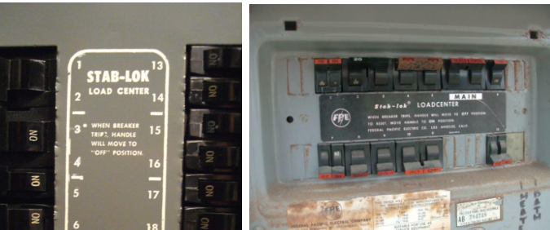
Identification:
- Identifying whether you have these panels is straight forward. The first indication that you may have FPE panels is a “Federal Pacific” or “FPE” label on the front of the panel.

- Next, examine the breaker handles themselves. Stab-Lok breakers are painted red. Look for the word “Stab-Lok” written on the panel face or on the label inside the cover door. It is most commonly found near the top of the panel between the two rows of breakers. Non-Stab-Lok panels are not painted red, but still have the same physical shape and design, and their numbering scheme is white lettering on a black background.

- Another visual clue is the white paint scheme used between the two breaker rows that annotates the breaker numbers. The corners are rounded, and there are tick marks separating the breaker numbers.

- Replacement Advice:
Because these panels are considered unsafe by industry standards, the primary recommendation is to have a licensed electrician replace the entire panel, rather than just replacing individual breakers.

History and Availability
- Manufacturer History: FPE went through several owners (Reliance Electric, Exxon, Rockwell, Baldor) after the brand was discontinued, with production stopping around 1990.
- Issues with Replacement Parts: Some re-certified or third-party breakers may not solve the underlying design issues of the panels.

Additional links
https://www.google.com/url?sa=t&rct=j&q=&esrc=s&source=web&cd=&ved=2ahUKEwiA2v_xwaKUAxVD6ckDHefaHs0QFnoECDQQAQ&url=https%3A%2F%2Fen.wikipedia.org%2Fwiki%2FStab-Lok&usg=AOvVaw1nhRtyP9c4nIcvNiVB_Zer&opi=89978449

Additional picture
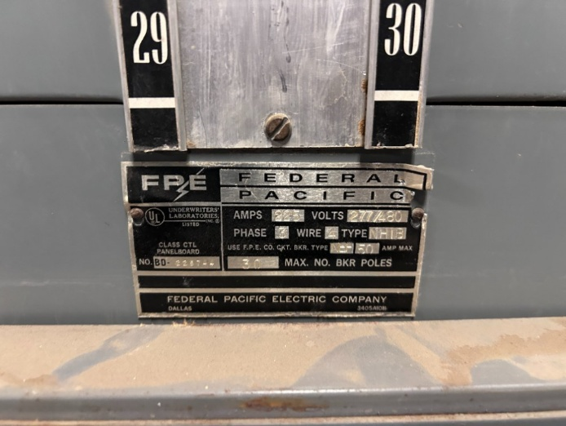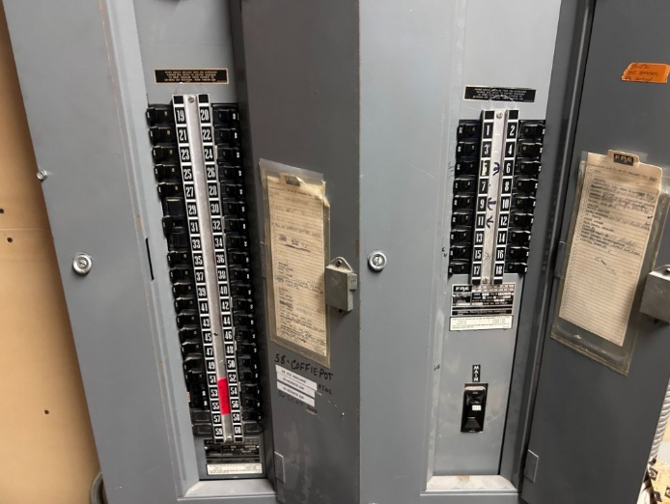
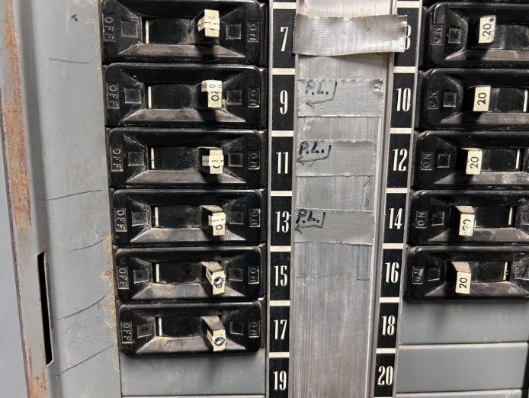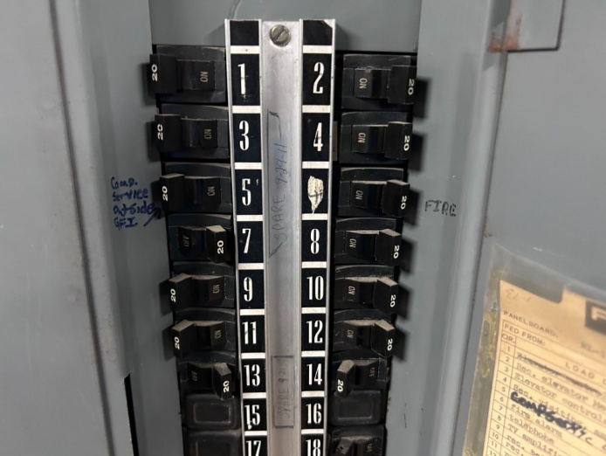
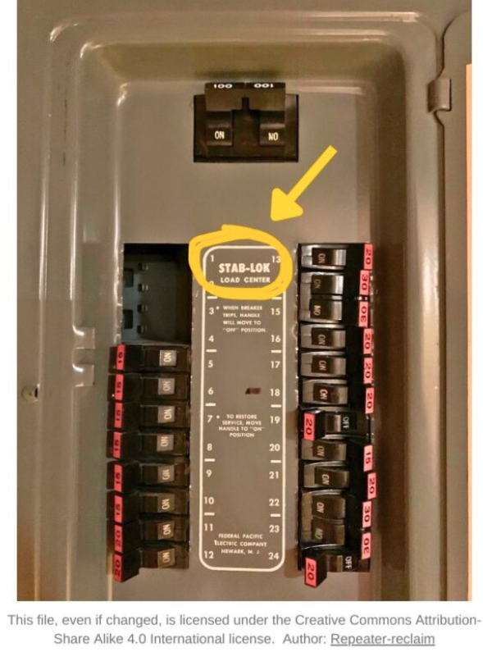

This document and any recommendations, analysis, or advice provided by Marsh (collectively, the “Marsh Analysis”) are not intended to be taken as advice regarding any individual situation and should not be relied upon as such. The information contained herein is based on sources we believe reliable, but we make no representation or warranty as to its accuracy. Marsh shall have no obligation to update the Marsh Analysis and shall have no liability to you or any other party arising out of this publication or any matter contained herein. Any statements concerning actuarial, tax, accounting, or legal matters are based solely on our experience as insurance brokers and risk consultants and are not to be relied upon as actuarial, tax, accounting, or legal advice, for which you should consult your own professional advisors. Any modeling, analytics, or projections are subject to inherent uncertainty, and the Marsh Analysis could be materially affected if any underlying assumptions, conditions, information, or factors are inaccurate or incomplete or should change. Marsh makes no representation or warranty concerning the application of policy wording or the financial condition or solvency of insurers or reinsurers. Marsh makes no assurances regarding the availability, cost, or terms of insurance coverage. Although Marsh may provide advice and recommendations, all decisions regarding the amount, type or terms of coverage are the ultimate responsibility of the insurance purchaser, who must decide on the specific coverage that is appropriate to its particular circumstances and financial position.

